**Workflows**

* **Models**: Manage workflow definitions
* **Instances**: View and manage running workflow instances
* **Launchers**: Manage how workflows are to be launched
* **Archive**: View history of workflows that completed successfully
* **Failures**: View history of workflows that completed with errors

**What is AEM Content Approval?**

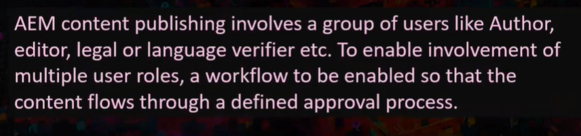

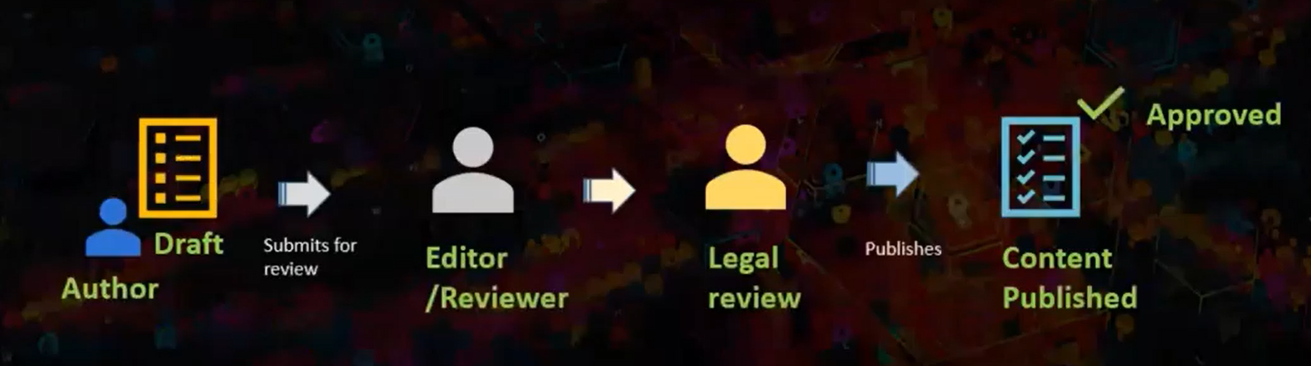

**Author** – Will draft the content and submits for review.

**Editor/Reviewer** – Will review the content and if there are any review changes, he will ask author to correct the changes. If the things are fine, he will pass it on to legal review.

**Legal review** – If there are some legal changes, he will ask back the author to update. If things are fine, he will ask for publishing.

Approved content will be published finally.

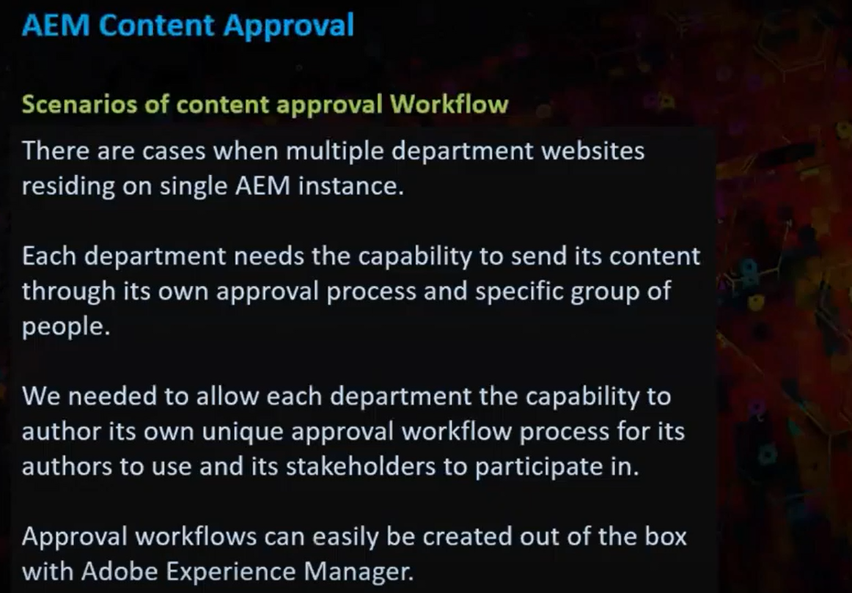

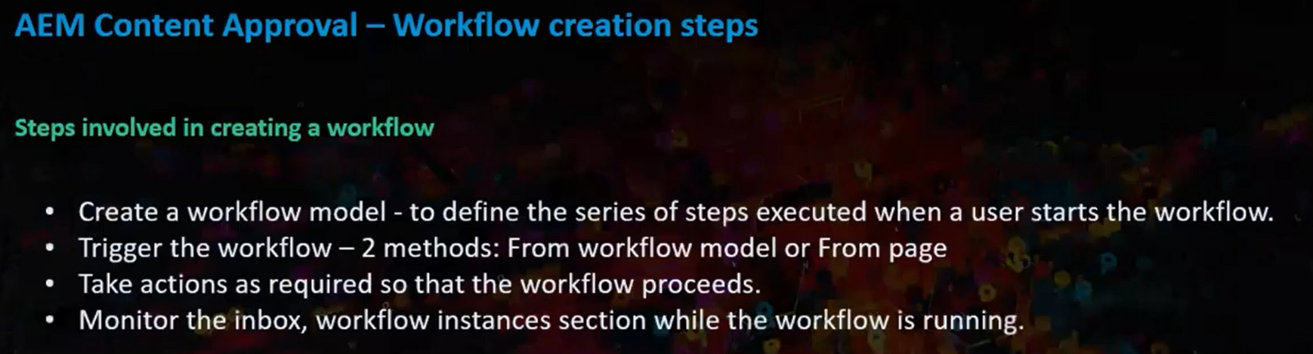

Let’s create a workflow and see how that works.

Steps:

1. Go to Tools -> Workflow -> Click on models to create a new model.

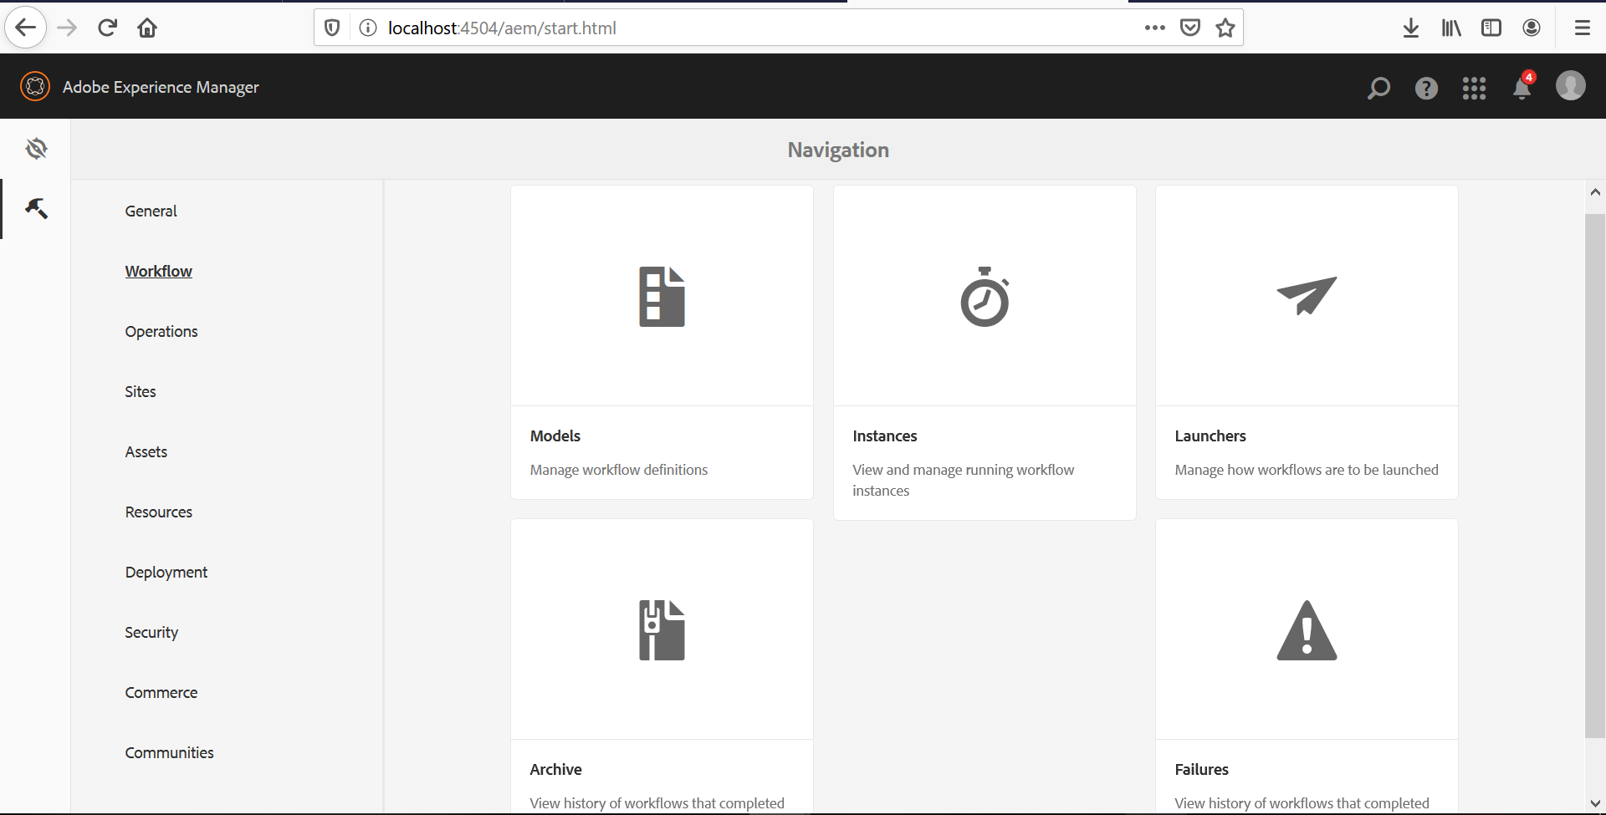

1. Once you click on models, click on create button and provide the model title and name.

Here I am providing the following details as mentioned below.

Title: AEM – Tutorial

Name: aem-content-approval

After providing the model details, click on “Done” button.

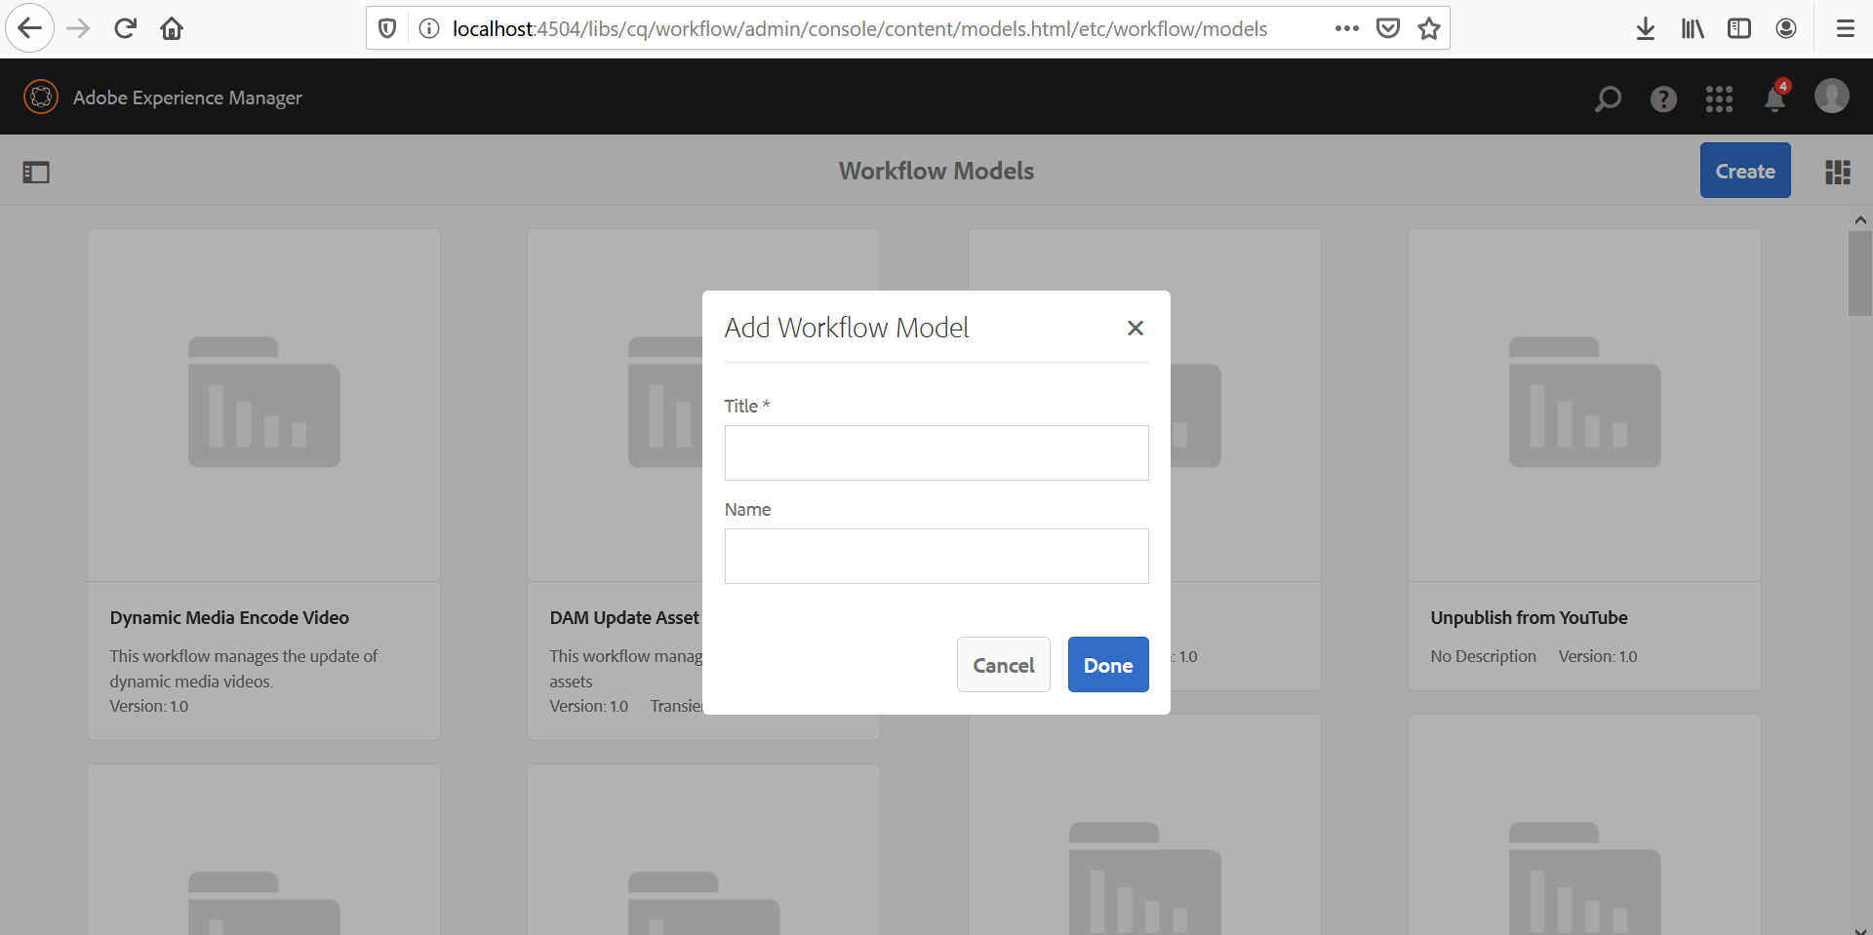

After creating a new model, it would get displayed in the list of models as shown below.

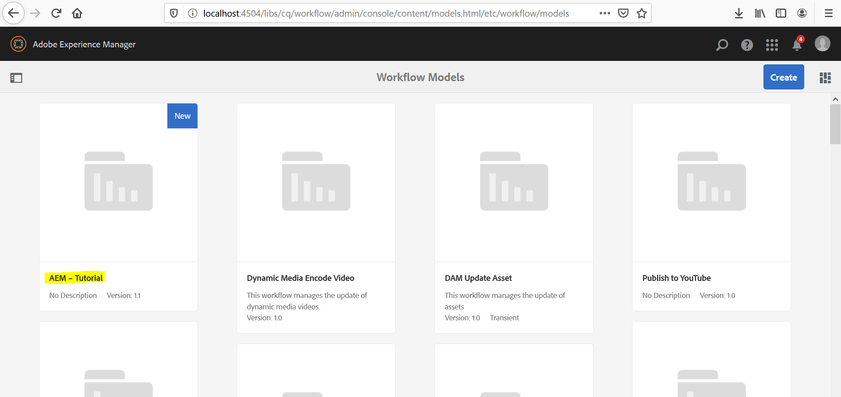

Select the model that we created and click on edit.